

Coffee Vending Machine

Real Times System

|  |  |  |
| --- | --- | --- |
| Name | ID | Major |
| Gloria Ezzat | 150753 | Software Engineering |
| Mostafa Wagih | 142864 | Software Engineering |
| Mohamed Mamdouh | 141295 | Software Engineering |
| Raggy Hosni | 144711 | Computer Science |

**GitHub link:** <https://github.com/ragrag/Coffee-Vending-Machine-RTS>

Table of Contents

**USE CASE DIAGRAM** 3

**USE CASE SCENARIOS** 4

**STIMULI-RESPONSE TABLE** 11

**STATE MACHINE DIAGRAM** 13

**CLASS DIAGRAM** 14

**SEQUENCE DIAGRAMS** 15

**CHOOSE DRINK** 15

**ENTER CREDIT** 16

**ORDER DRINK** 17

**CANCEL ORDER** 17

# **USE CASE DIAGRAM**

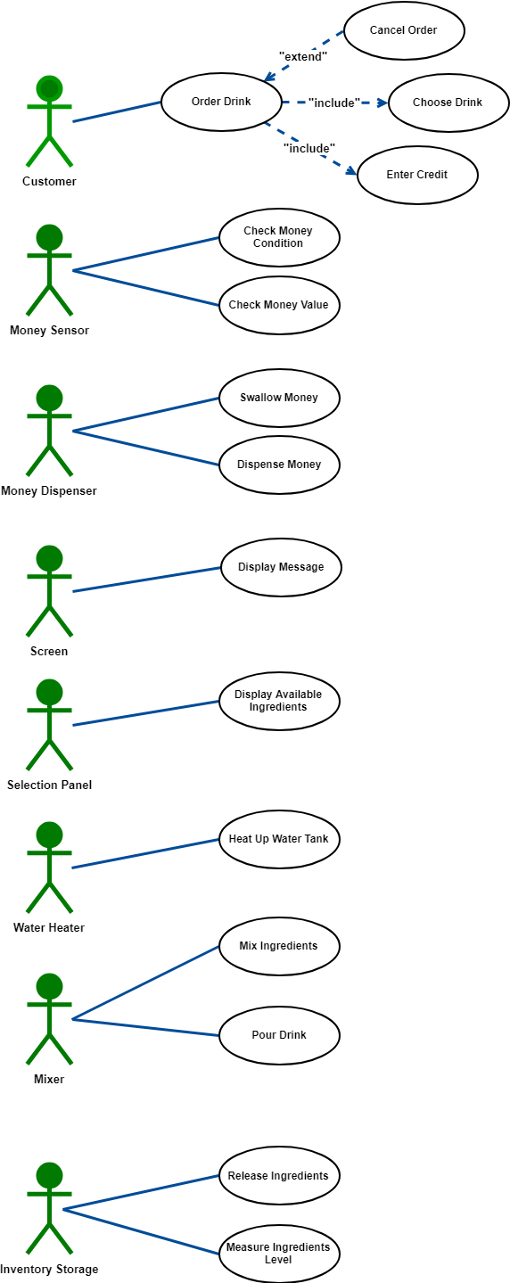

# **USE CASE SCENARIOS**

**First Use Case**: Order Drink

|  |  |
| --- | --- |
| ID | UC-01 |
| Title | Order Drink. |
| Description | This is Considered the most fundamental use case as the user goes through the process of selecting the specifications (Type-Sugar-Size) of his drink |
| Primary Actor | Customer |
| Supporting Actor(s) | Money Sensor  Money Dispenser  Selection Panel  Screen |
| Preconditions | Power on to the system coffee vending machine |
| Basic Flow of Events | 1.The User enters his credit  2.The user selects the Specifications of his drink |
| Extensions | 2.a.If the user inputs orders something he didn’t enter proper amount of credit for   1. The system displays current credit 2. No drink is provided for the user |
| Post Conditions | A drink will be served to the user |
| Priority | High |

**Second Use Case**: Enter Credit

|  |  |
| --- | --- |
| ID | UC-02 |
| Title | Enter Credit |
| Description | The User inputs his money in the Dispenser |
| Primary Actor | Customer |
| Supporting Actor(s) | Money Sensor  Money Dispenser |
| Preconditions | Power on to the system vending machine |
| Basic Flow of Events | 1. The user inputs his money in the Dispenser 2. The Money sensor authenticates the money |
| Extensions | 1.a. The User does not Input his money properly  1.The System doesn’t update the Balance Value |
| Post Conditions | The User Balance Will be updated |
| Priority | High |

**Third Use Case**: Choose Drink

|  |  |
| --- | --- |
| ID | UC-03 |
| Title | Choose Drink |
| Description | The User is selecting the specifications for his drink from the selection panel |
| Primary Actor | Customer |
| Supporting Actor(s) | Selection Panel  Screen |
| Preconditions | The User Enters Credit in the Machine |
| Basic Flow of Events | 1. The selection panel allows the user to select the type of drink he wants. 2. The selection panel allows the user to select the size of drink he wants. 3. The selection panel allows the user to select the amount of sugar in his drink. 4. The user clicks start |
| Extensions | 1.a. If the user did not specify a type  1.The system do not begin the transaction and display a message “Please select drink first”  2.a. If the user did not specify a size  1.The system puts default size of small  3.a.If the user did not specify amount of sugar  1.The system puts a default value of none |
| Post Conditions | The Process of preparing the Drink is initiated |
| Priority | High |

**Fourth Use Case**: Cancel order

|  |  |
| --- | --- |
| ID | UC-04 |
| Title | Cancel order |
| Description | The User wishes to cancel his order |
| Primary Actor | Customer |
| Supporting Actor(s) | Selection panel  Screen |
| Preconditions | The User enters credit in the machine |
| Basic Flow of Events | 1. The users select the cancel button on the selection panel |
| Extensions | 1.a. If the user selects the cancel button after pressing start  1.The System will continue the process of preparing the drink as the cancel button is disabled |
| Post Conditions | The Machine will dispense money equal to the customer balance |
| Priority | High |

**Fifth Use Case**: Check Money Condition

|  |  |
| --- | --- |
| ID | UC-05 |
| Title | Check Money Condition |
| Description | The Sensor is checking the quality of the money to be added to the user balance |
| Primary Actor | Money Sensor |
| Supporting Actor(s) | Money Dispenser |
| Preconditions | The User Inputted Credit in the Machine |
| Basic Flow of Events | 1. The Sensor checks the quality of the money inputted |
| Extensions | None |
| Post Conditions | The money will be accepted by the dispenser and added to the customer balance or rejected and dispensed back. |
| Priority | Medium |

**Sixth Use Case**: Check Money Value

|  |  |
| --- | --- |
| ID | UC-05 |
| Title | Check Money Value |
| Description | The Sensor is checking the amount of the money that the users input. |
| Primary Actor | Money Sensor |
| Supporting Actor(s) | Money Dispenser |
| Preconditions | The User Inputted Credit in the Machine |
| Basic Flow of Events | 1. The Sensor Check the amount of the money inputted |
| Extensions | None |
| Post Conditions | The money will be accepted by the dispenser and added to the customer balance or rejected and dispensed back. |
| Priority | Medium |

**Seventh Use Case**: Swallow Money

|  |  |
| --- | --- |
| ID | UC-07 |
| Title | Swallow Money |
| Description | The Dispenser Swallows the money of the user |
| Primary Actor | Money Dispenser |
| Supporting Actor(s) | None |
| Preconditions | The User Inputted money in the Machine |
| Basic Flow of Events | 1. The Dispenser swallows the money from the user. |
| Extensions | None |
| Post Conditions | The money will be authenticated |
| Priority | Medium |

**Eighth Use Case**: Dispense Money

|  |  |
| --- | --- |
| ID | UC-08 |
| Title | Dispense Money |
| Description | The machine returns money to the user either due to rejection of quality or as change from his order or if the user cancels his order. |
| Primary Actor | Money Dispenser |
| Supporting Actor(s) | None |
| Preconditions | The User Must have inputted money |
| Basic Flow of Events | 1. The dispenser dispenses the money to the user |
| Extensions | None |
| Post Conditions | The Customer balance will remain to zero. |
| Priority | High |

**Ninth Use Case**: Display message

|  |  |
| --- | --- |
| ID | UC-09 |
| Title | Display Message |
| Description | The message requested by the system is displayed to the user |
| Primary Actor | Screen |
| Supporting Actor(s) | Selection panel  Mixer |
| Preconditions | Power on to the vending machine system |
| Basic Flow of Events | 1. A certain system message is displayed in the screen. |
| Extensions | None |
| Post Conditions | A message will be displayed for the user to read it. |
| Priority | Low |

**Tenth Use Case**: Display Available Ingredients

|  |  |
| --- | --- |
| ID | UC-10 |
| Title | Display Available Ingredients |
| Description | The selection panel receives which ingredients are available, and shows it to the user by showing green lights next to the available drinks |
| Primary Actor | Selection panel |
| Supporting Actor(s) | Inventory Storage |
| Preconditions | Power on to the vending machine system |
| Basic Flow of Events | 1. The selection panel displays the available Drinks ready to be served. |
| Extensions | None |
| Post Conditions | 1. Green light will be displayed next to the available drink due to presence of ingredients. 2. Red light will be displayed next to the unavailable drink due to lack of Ingredients. |
| Priority | Medium |

**Eleventh Use Case**: Heat Up Water Tank

|  |  |
| --- | --- |
| ID | UC-11 |
| Title | Heat Up Water Tank |
| Description | The water tank heats up the water to maintain the temperature |
| Primary Actor | Water Heater |
| Supporting Actor(s) | None |
| Preconditions | Power on to the vending machine system |
| Basic Flow of Events | 1. The heater increases the temperature of the tank until it reaches 80°C 2. The heater stops when the tank temperature is at 80°C 3. When the temperature drops to 40°C, it restarts the heating process |
| Extensions | None |
| Post Conditions | The water tank temperature will be sustained between 40°C and 80°C. |
| Priority | High |

**Twelfth Use Case**: Mix Ingredients

|  |  |
| --- | --- |
| ID | UC-12 |
| Title | Mix Ingredients |
| Description | The mixer allocates required Ingredients and mixes them together |
| Primary Actor | Mixer |
| Supporting Actor(s) | Inventory Storage |
| Preconditions | 1. The User must have selected a drink along with its specifications. 2. The user selected start. |
| Basic Flow of Events | 1. The Mixer Allocates ingredients from Inventory. 2. The mixer mixes the ingredients. |
| Extensions | None |
| Post Conditions | The Drink will be ready to be poured. |
| Priority | High |

**Thirteenth Use Case**: Pour Drink

|  |  |
| --- | --- |
| ID | UC-13 |
| Title | Pour Drinks |
| Description | The mixer pours the drink to the user |
| Primary Actor | Mixer |
| Supporting Actor(s) | None |
| Preconditions | The Drink is allocated and mixed. |
| Basic Flow of Events | 1.The Drink is poured from the machine. |
| Extensions | None |
| Post Conditions | The Drink will be poured. |
| Priority | Medium |

**Fourteenth Use Case**: Release Ingredients

|  |  |
| --- | --- |
| ID | UC-14 |
| Title | Release Ingredients |
| Description | The Inventory Storage release the ingredient for drink preparation |
| Primary Actor | Inventory Storage |
| Supporting Actor(s) | None |
| Preconditions | The mixer requests ingredients. |
| Basic Flow of Events | 1.The Ingredients are released to the mixer |
| Extensions | None |
| Post Conditions | The Ingredients reach the mixer. |
| Priority | Medium |

**Fifteenth Use Case**: Measure Ingredients level

|  |  |
| --- | --- |
| ID | UC-15 |
| Title | Measure Ingredients Level |
| Description | The Inventory Storage detects the levels of each ingredient. |
| Primary Actor | Inventory Storage |
| Supporting Actor(s) | None |
| Preconditions | Power on to the vending machine system |
| Basic Flow of Events | 1.The Ingredients are assessed |
| Extensions | None |
| Post Conditions | The Ingredients levels are displayed for illustration |
| Priority | Medium |

# **STIMULI-RESPONSE TABLE**

|  |  |  |
| --- | --- | --- |
| Stimuli | Response | Response Time |
| Open with key | Transition from (Down) state to (Under maintenance) state. | <5 seconds |
| Close with key | Transition from (Under maintenance) state to (Down) state. | <5 seconds |
| Turn on | Transition from (Down) state to (Idle) state  Action: display “Hello”, display balance, display  available ingredients.  Turn on water heater. | <1 second |
| Turn off | Transition from any state to (Down) state. Action: display “Thank you Goodbye :)” | <2 seconds |
| Insert money | Transition from (Idle) state to (Validating money) state. | <3 seconds |
| Money authenticated | Transition from (Checking money condition) sub-state to (Checking money value) sub-state. | <5 seconds |
| Money valid | Transition from (Validating money) state to (Idle) state. Action: display balance, display available ingredients, accumulate balance. | <2 seconds |
| Money invalid | Transition from (Validating money) state to (Idle) state.  Action: display balance, display “Bad money condition”, display available ingredients, return money. | <3 seconds |
| Initiate selection | Transition from (Idle) state to (Waiting for selection) state. | <2 seconds |
| Cancel order | Transition from (Waiting for selection) state to (Idle) state.  Action: display balance, display available ingredients, return money. | <5 seconds |
| Select type | Transition from (Waiting for selection) state to (Waiting for selection) state.  Activity: display selections. | <1 second |
| Select size | Transition from (Waiting for selection) state to (Waiting for selection) state.  Activity: display selections. | <1 second |
| Select sugar | Transition from (Waiting for selection) state to (Waiting for selection) state.  Activity: display selections. | <1 second |
| Click start [balance<price, coffee type is not selected, ingredients selected are not sufficient] | Transition from (Waiting for selection) state to (Waiting for selection) state. | <1 second |
| Click start [balance>=price, coffee type is selected, ingredients selected are sufficient] | Transition from (Waiting for selection) state to (Preparing coffee) state.  Action: display “Wait for your drink”  Activity: retrieving cup. | <1 second |
| Cup retrieved | Transition from (Retrieve cup) sub-state to (Retrieve coffee) sub-state.  Activity: retrieving coffee. | <1 second |
| Coffee retrieved | Transition from (Retrieve coffee) sub-state to (Retrieve sugar) sub-state.  Activity: retrieving sugar. | <1 second |
| Sugar retrieved | Transition from (Retrieve sugar) sub-state to (Retrieve water) sub-state.  Activity: retrieving water. | <1 second |
| Order components retrieved | Transition from (Extract needs) sub-state to (Mixing ingredients) sub-state.  Activity: mix ingredients. | <3 seconds |
| Ingredients mixed | Transition from (Mixing ingredients) sub-state to ( Pouring coffee) state.  Activity: pouring coffee. | <2 seconds |
| Pouring finished | Transition from (Pouring) state to (Idle) state.  Action: return change (if any), extract drink, display balance, display available ingredients. | <5 seconds |
| Sensor detects temperature below threshold | Transition from (Not heating) state to (Heating) state.  Activity: heat water tank. | <2 minutes |
| Sensor detects temperature above threshold | Transition from (Heating) state to (Not heating) state.  Action: stop heating. | <2 minutes |

# **STATE MACHINE DIAGRAM**

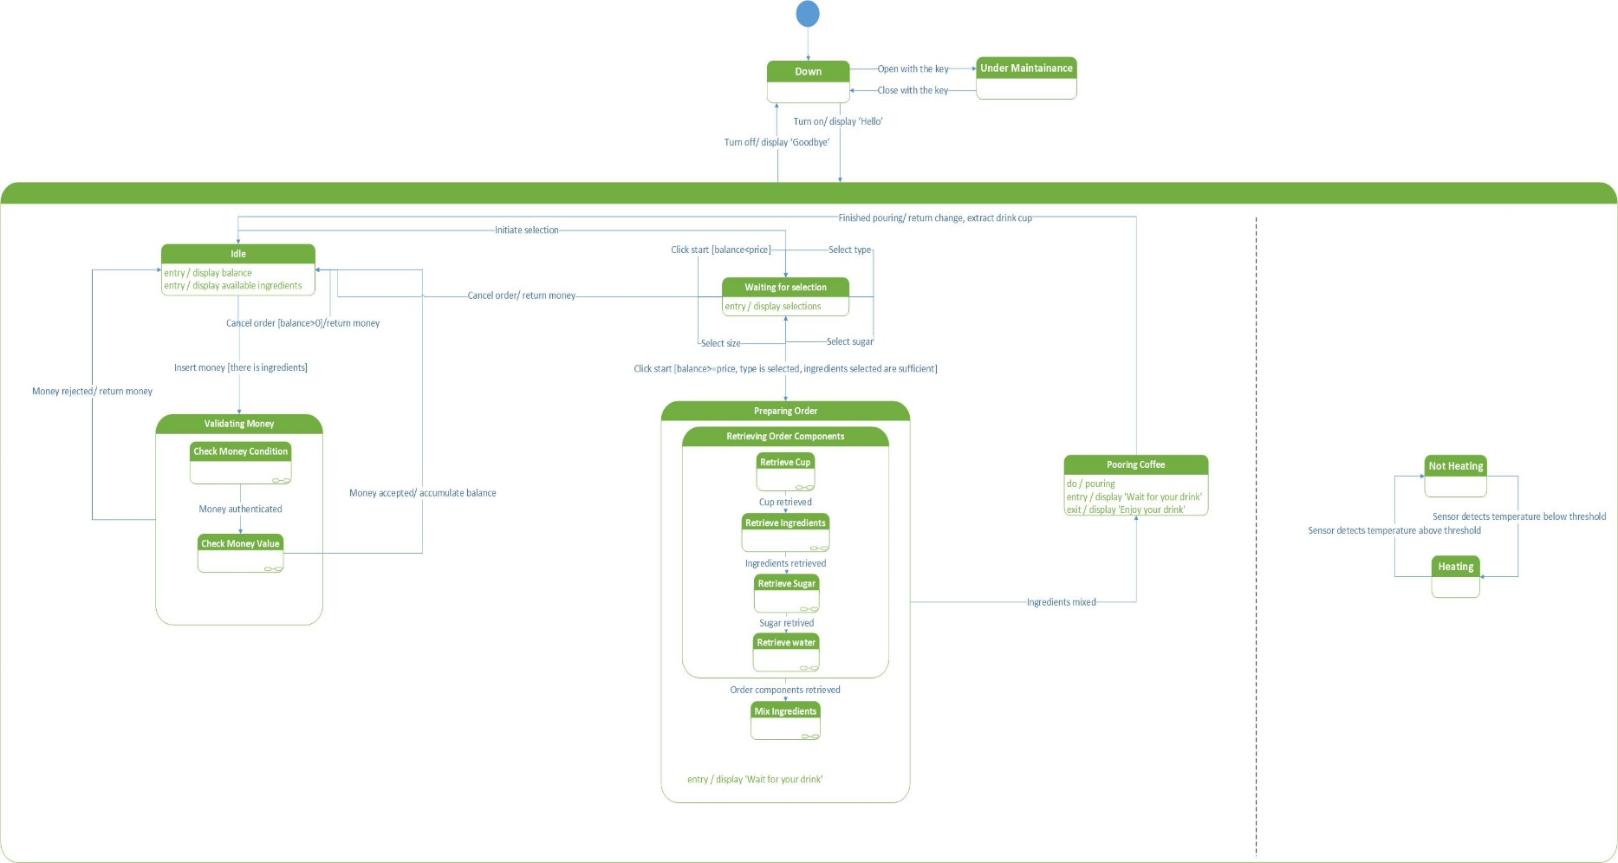

# **CLASS DIAGRAM**

# **SEQUENCE DIAGRAMS**

## **CHOOSE DRINK**

## **ENTER CREDIT**

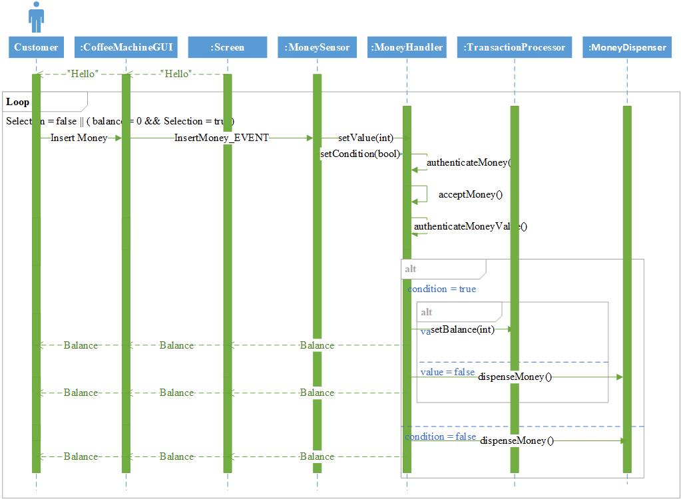

## **ORDER DRINK**

## **CANCEL ORDER**